**Leaders Image Prediction using CNN**

**Project Description:**

This project aims to develop an advanced image classification system that can accurately predict images of four distinct leaders. To achieve this, we have curated a high-quality dataset of images sourced from Google and other publicly available repositories. Our system leverages the power of Convolutional Neural Networks (CNNs), a deep learning architecture well-suited for image recognition tasks, to analyse and classify these leader images.

Our system is designed to provide a robust and accurate prediction capability, paving the way for more sophisticated image recognition systems in the future. The final system will be deployed with a user-friendly interface, allowing users to upload images and receive instant feedback on predicting the leader's name.

**Scenario 1: Leader Image Classification Using CNNs**

Develop an AI model that analyses images of four leaders to classify them into different categories. The model can be trained using image features such as facial structure, colour patterns, and distinct visual attributes to ensure accurate classification based on the specific characteristics of each leader.

**Scenario 2: AI-Powered Leader Recognition System**

Create a real-time AI system for automated leader image recognition. The system could utilize computer vision and machine learning techniques to assess leader images based on their visual characteristics and classify them accurately. This system would streamline the process of recognizing and categorizing leader images with high precision.

**Scenario 3: Predictive Maintenance for Leader Image Classification Model**

Implement an AI-driven monitoring system that evaluates the performance of the leader image classification model over time. The system can track factors such as image quality, model performance, and data drift, alerting operators to potential issues before they impact the classification accuracy, ensuring that the system continues to perform optimally during operation.

**Technical Architecture:**

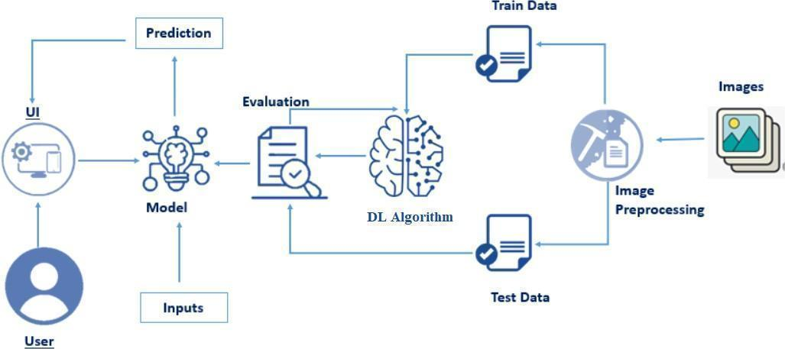

**Prerequisites:**

**To complete this project, you must require the following software, concepts, and packages**

* **Jupyter Notebook**
* Refer to the link below to download Jupyter Notebook
* Link (Jupyter Notebook): <https://jupyter.org/>
* Link (Spyder): https://www.youtube.com/watch?v=8YGPfGDYAgI
* **Python packages:**
* Type the below installation statements in the Jupyter notebook cells and install them.
* Type “pip install numpy” and click enter.
* Type “pip install pandas” and click enter.
* Type “pip install tensorflow” and click enter.
* Type “pip install keras” and click enter.
* Type “pip install Flask” and click enter.

**Prior Knowledge:**

You must have prior knowledge of the following topics to complete this project.

* **Deep Learning Concepts**
* **Neural Networks:** <https://www.youtube.com/watch?v=bfmFfD2RIcg>
* **CNN:** <https://www.youtube.com/watch?v=zfiSAzpy9NM>
* **Architecture :** <https://www.v7labs.com/blog/convolutional-neural-networks-guide>
* **Flask:** Flask is a popular Python web framework, meaning it is a third-party Python library used for developing web applications.

Link: <https://www.youtube.com/watch?v=4L_xAWDRs7w&t=1s>

**Project Objectives:**

By the end of this project, you’ll understand the following:

●       Preprocessing the images.

●       Applying Convolution Neural Networks on the dataset.

●       How deep neural networks predicting the name and gender of the cat.

●       You will be able to know how to find the accuracy of the model.

●       You will be able to Build web applications using the Flask framework.

**Project Flow:**

* The user interacts with the UI (User Interface) to choose the image.
* The chosen image is analysed by the model which is integrated with flask application.
* The Model analyses the image, then the prediction is showcased on the Flask UI.

To accomplish this, we have to complete all the activities and tasks listed below

* Data Collection.
* Create a Train and Test path.
* Data Pre-processing.
* Import the required library
* Configure ImageDataGenerator class
* Apply ImageDataGenerator functionality to Trainset and Test set
* Model Building
* Convolution and Max Pooling
* Flattening
* Neural Network Connection
* Training the Model
* Save the Model
* Test the Model
* Application Building
* Create an HTML file
* Build Python Code

**Project Structure:**

Create a Project folder that contains files as shown below

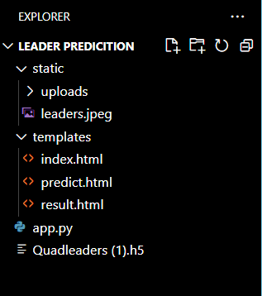

* We are building a Flask Application that needs HTML pages stored in the **templates folder.**
* Python script **app.py** for server-side scripting
* we need the model that is saved and the saved model in this content is

**Quadleaders(1).h5**

* templates folder contains index.html, predict.html & result.html pages.

**Milestone 1: Data Collection**

  There are many popular open sources for collecting the data. Eg: kaggle.com, UCI repository, etc.

**Activity 1: Download the dataset**

It is the most crucial aspect that makes algorithm training possible. So this section allows you to download the required dataset.

There are many popular open sources for collecting the data. Eg: kaggle.com, UCI repository, etc.

In this project, we have used Quadleaders data. This data is downloaded from kaggle.com. Please refer to the link given below to download the dataset.

Link:<https://www.kaggle.com/datasets/anandkumarsahu09/quad-leaders-image-dataset-2022?select=Quad+Leaders>

As the dataset is downloaded. Let us understand the data properly.

Note: There are several techniques for understanding the data. But here we have used some of it. In an additional way, you can use multiple techniques

   We are going to build our training model on Jupyter Notebook.

**Activity 2: Create training and testing dataset**

In our project, we are working with a dataset containing four classes. The dataset was directly downloaded, and we utilized a split function in the code to divide it into training and testing sets. The image input size for our model is set to 150x150. We have not employed any transfer learning models for this task; instead, we focused on building the model from scratch for image classification purposes.

**Milestone 2: Image Preprocessing**

In this milestone, we will be improving the image data that suppresses unwilling distortions or enhances some image features important for further processing, although performing some geometric transformations of images like rotation, scaling, translation, etc.

**Activity 1: Importing the libraries**

Import the necessary libraries as shown in the image

.

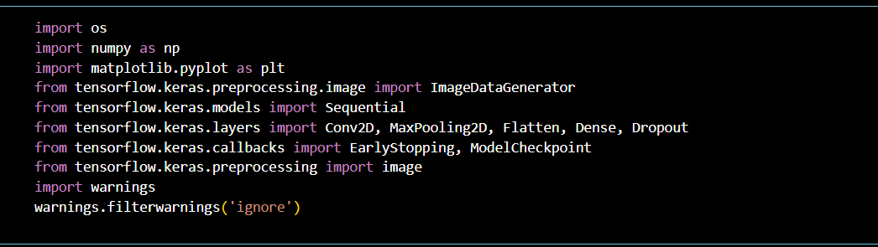

**Activity 2: Configure ImageDataGenerator class**

ImageDataGenerator class is instantiated and the configuration for the types of data augmentation

There are five main types of data augmentation techniques for image data; specifically:

* Image shifts via the width_shift_range and height_shift_range arguments.
* The image flips via the horizontal_flip and vertical_flip arguments.
* Image rotations via the rotation_range argument
* Image brightness via the brightness_range argument.
* Image zoom via the zoom_range argument.
* The image data have a split for train and test with validation_split.

An instance of the ImageDataGenerator class can be constructed for train and test.

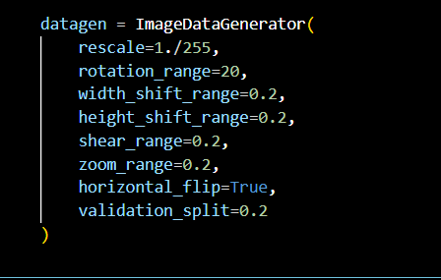

**Activity 3: Apply ImageDataGenerator functionality to Training_data and Validation_data**

We apply the ImageDataGenerator functionality to the training and validation datasets using the flow_from_directory method. This method returns batches of images categorized by subdirectories. Key arguments include:

* dataset_dir: The directory where the image data is stored.
* batch_size: Set to 16, determining the number of images in each batch.
* target_size: Resizes images to (150, 150) after loading from disk.
* class_mode: Set to 'categorical', meaning that labels are encoded as categorical vectors, which is useful for multi-class classification tasks, as shown in the image.

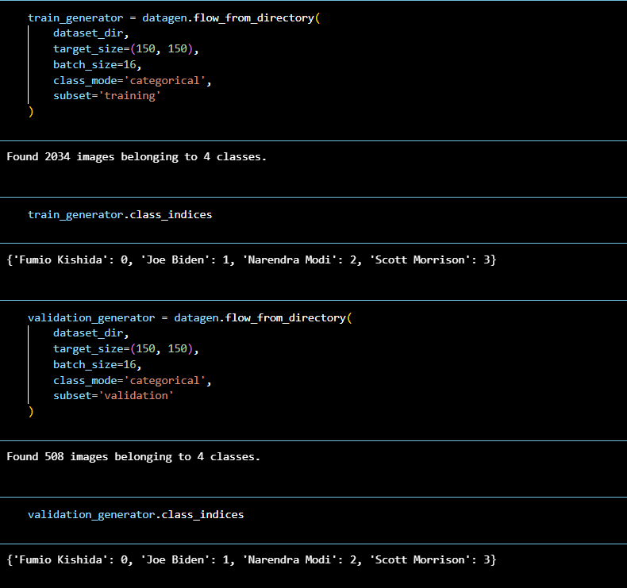

**Milestone 3: Model Building**

Now it's time to build our model. Deep understanding of the model – Link is referred to in the prior knowledge section. Kindly refer to it before starting the model-building part.

**Activity 1: Convolution and Max Pooling**

In this CNN model created using the Sequential API in Keras, the input images are of size **150x150** pixels with **3 color channels (RGB)**. The model contains three convolutional layers, each followed by a max pooling layer.

* The first convolutional layer applies **32 filters** with a **3x3 kernel size** and ReLU activation, and the input shape is specified as **(150, 150, 3)**.
* The second convolutional layer uses **64 filters**, a **3x3 kernel**, and ReLU activation.
* The third convolutional layer utilizes **128 filters** with a **2x2 kernel size** and ReLU activation

Each convolutional layer is followed by a max pooling operation with a **2x2 pool size** to reduce spatial dimensions. After these layers, a **Flatten** layer would typically follow to convert the 3D feature maps into a 1D vector, ready for fully connected layers.

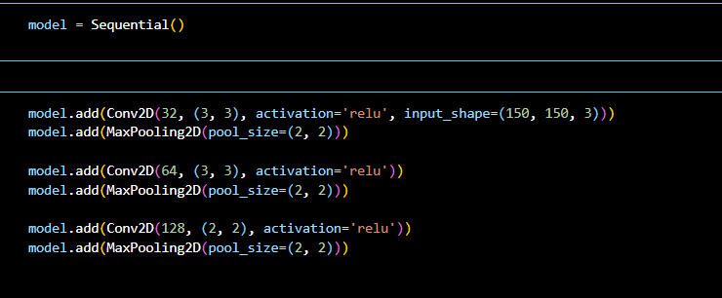

**Activity 2: Flattening**

Flattening converts the matrix in to single dimension array and can be used for building the Neural Network

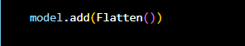

**Activity 3: Neural Network Connection**

The model includes a Dense layer with 512 neurons using the ReLU activation function, followed by a Dropout layer with a 0.5 dropout rate to prevent overfitting. The final Dense layer consists of 4 neurons with a Softmax activation function, which outputs probabilities for a 4-class classification problem.

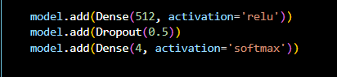

**Activity4: Model Summary**

This CNN model consists of three convolutional layers with 32, 64, and 128 filters, each followed by max-pooling layers. The output from the convolutional layers is flattened before passing through a dense layer with 512 neurons and ReLU activation, followed by a dropout layer to prevent overfitting. The final dense layer has 4 neurons with softmax activation for multi-class classification. The model has a total of 18,994,756 trainable parameters.

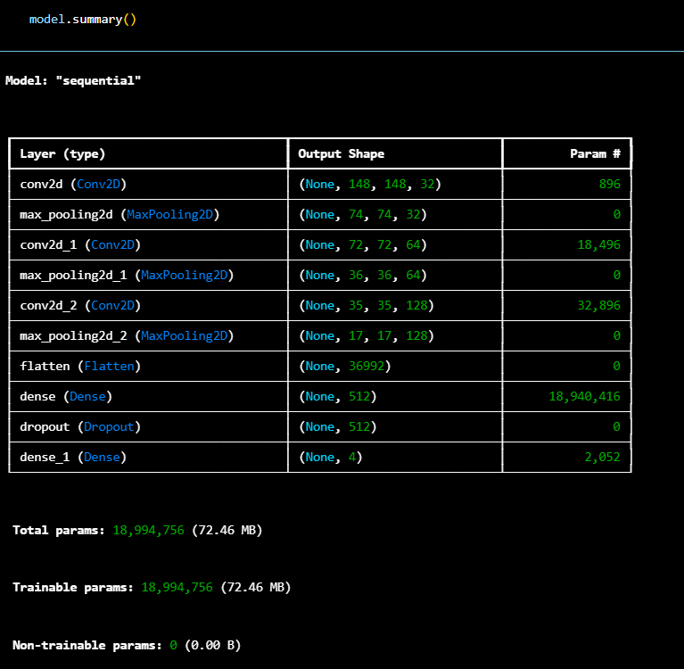

**Activity 5: Configure the Learning Process**

The model is compiled using the **Adam optimizer**, which adjusts the learning rate during training, and the **categorical crossentropy** loss function, which is used for multi-class classification problems. The model will evaluate its performance using **accuracy** as a metric, which measures the proportion of correct predictions. Once the model is compiled, it is ready for training.



**Activity 6: Train the model**

In the training phase of the model, the **EarlyStopping** callback is implemented to monitor the validation loss (val_loss), with a patience of 5 epochs, meaning training will stop if there is no improvement in the validation loss for 5 consecutive epochs. Additionally, **ModelCheckpoint** saves the model with the least validation loss, ensuring that the best-performing model is retained.

The model is trained for **30 epochs** (as shown in the image) using the **train_generator** for training data and **validation_generator** for validation data. The training process is optimized using the early stopping and model checkpoint callbacks to prevent overfitting and ensure the best model is saved.

**Fit** function is used to train a deep-learning neural network.

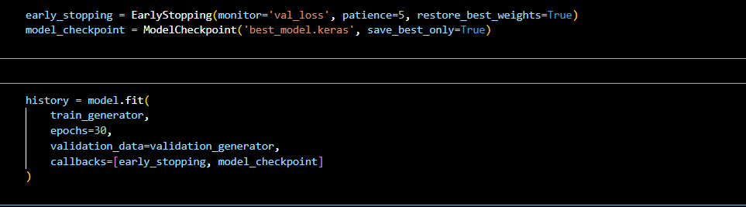

**Arguments:**

In this phase of training, we define several important arguments for the model.fit() function:

* **steps_per_epoch**: This defines the number of batches of samples to process before moving to the next epoch. It is calculated as the total number of samples in the dataset divided by the batch size.
* **epochs**: Specifies the total number of complete passes through the training dataset, where the model’s weights are updated after each epoch.
* **validation_data**: This can be a list of input-target pairs, a generator that yields such pairs, or an input-target-sample_weight list. It is used to evaluate the loss and metrics after every epoch.
* **validation_steps**: This is used only when validation_data is a generator. It defines how many batches of validation data the model processes at the end of every epoch, typically calculated as the total validation data points divided by the batch size.

By monitoring the training, we can observe fluctuations in accuracy across epochs, sometimes achieving the same accuracy. However, over time, we expect to see an overall improvement in accuracy as the model continues to learn from the data.

**Activity 7: Save the Model**

Saving the model after calculating the train and test accuracy.

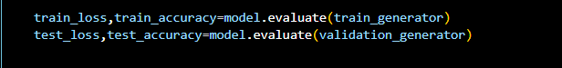

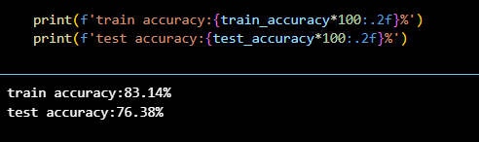

**Activity 8: Testing the Model**

Model testing is the process of evaluating the performance of a deep learning model on a dataset that it has not seen before. It is a crucial step in the development of any machine learning model, as it helps to determine how well the model can generalize to new data.

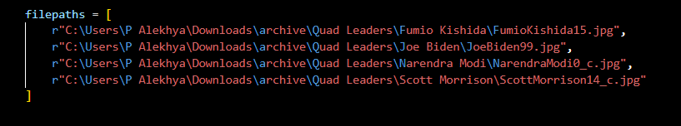



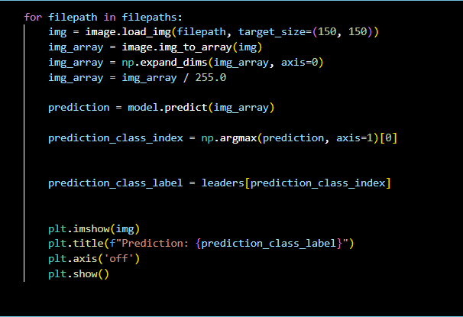

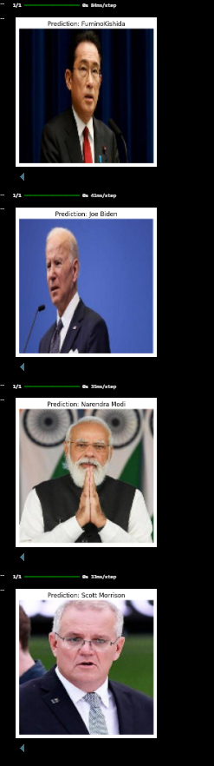

* In the above code, we have tested the model with an images of a leaders.

**Milestone 4: Save the Model**

The model is saved with .h5 extension as follows

An H5 file is a data file saved in the Hierarchical Data Format (HDF). It contains multidimensional arrays of scientific data.

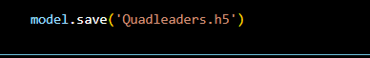

**Milestone 5: Application Building**

In this section, we will be building a web application that is integrated to the model we built. A UI is provided for the uses where he has to enter the values for predictions. The enter values are given to the saved model and prediction is showcased on the UI.

This section has the following tasks

* Building HTML Pages
* Building server-side script

**Activity1: Building Html Pages:**

For this project create one HTML file namely

* Index.html

Let’s see how our index.html page looks like:



When you click on about buttons on the top, you will be redirecting to the following pages





**Activity 2: Build Python code:**

* Import the libraries
* Loading the saved model and initializing the Flask app
* Render HTML pages:
* Once we upload the file into the app, then verifying the file uploaded properly or not. Here we will be using the declared constructor to route to the HTML page that we have created earlier.
* In the above example, ‘/’ URL is bound with home.html function. Hence, when the home page of the web server is opened in the browser, the HTML page will be rendered. Whenever you enter the values from the html page the values can be retrieved using POST Method.

Here we are routing our app to res function. This function retrieves all the values from the HTML page using a Post request. That is stored in an array. This array is passed to the predict function. This function returns the prediction. This prediction value will rendered to the text that we have mentioned in the index.html page earlier.

**Activity 3: Run the application**

* Open the VS Code from the start menu.
* Navigate to the folder where your Python script is.
* Now type the “python app.py” command.
* Navigate to the localhost where you can view your web page.
* Click on the predict button from the top right corner, enter the inputs, click on the submit button, and see the result/prediction on the web.

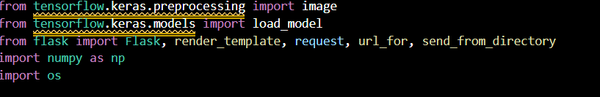

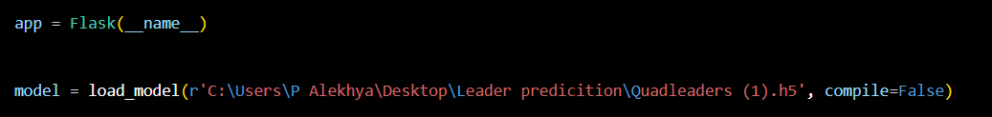

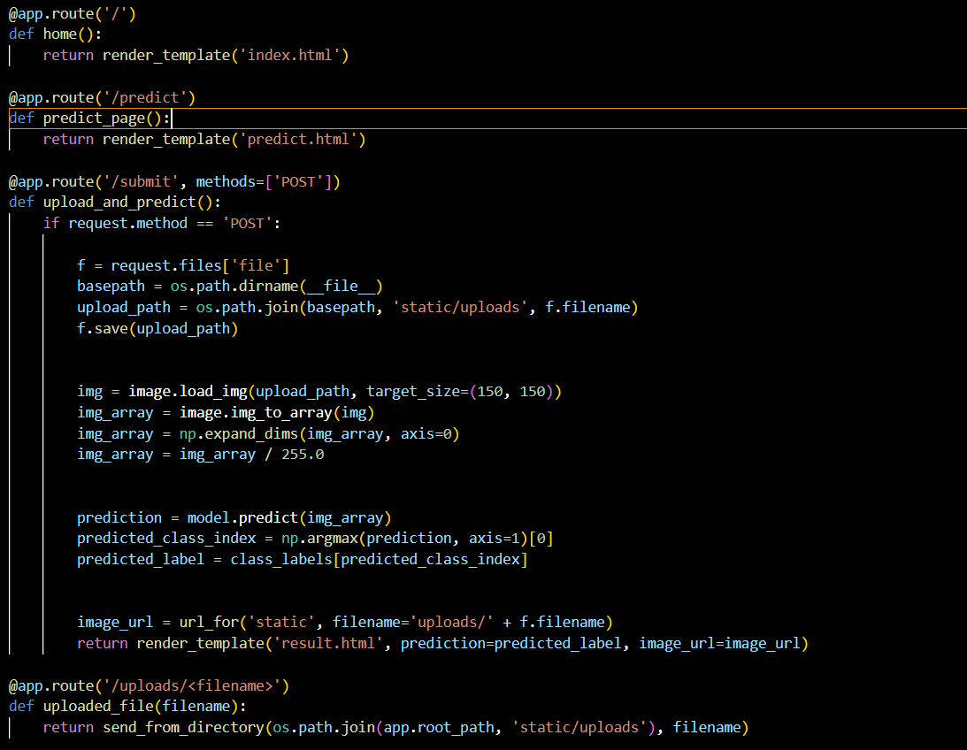

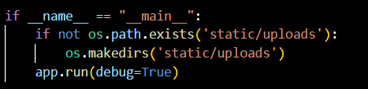

click on Get started button



Once you upload the image and click on the submit button, the output will be displayed on the below page

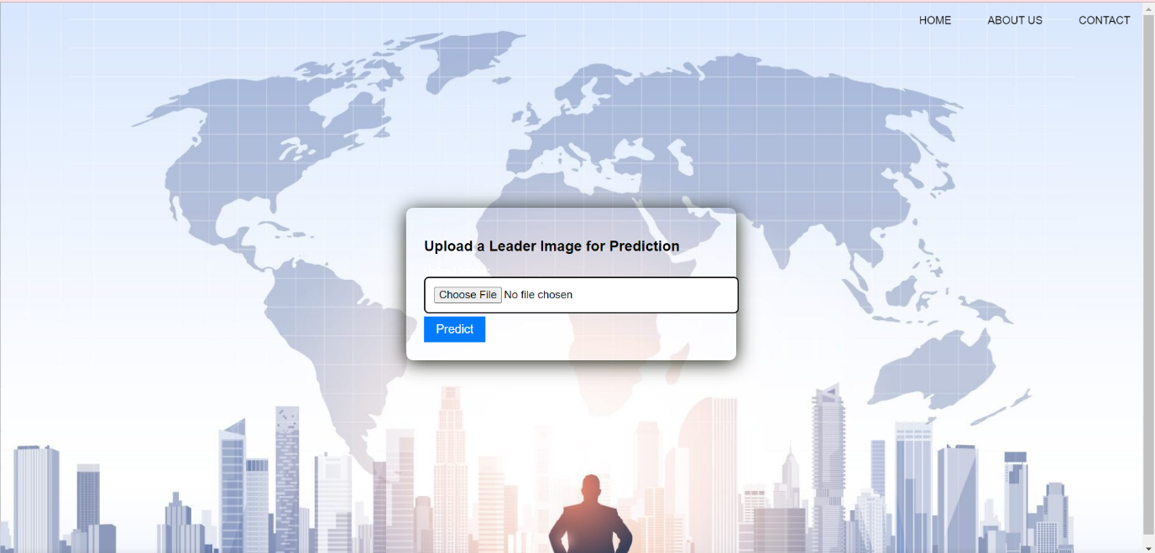

**Output:1**



**Output:2**



**Output:3**



**Output:4**

